

ACADEMY 2026-27
APPLICATION PACK

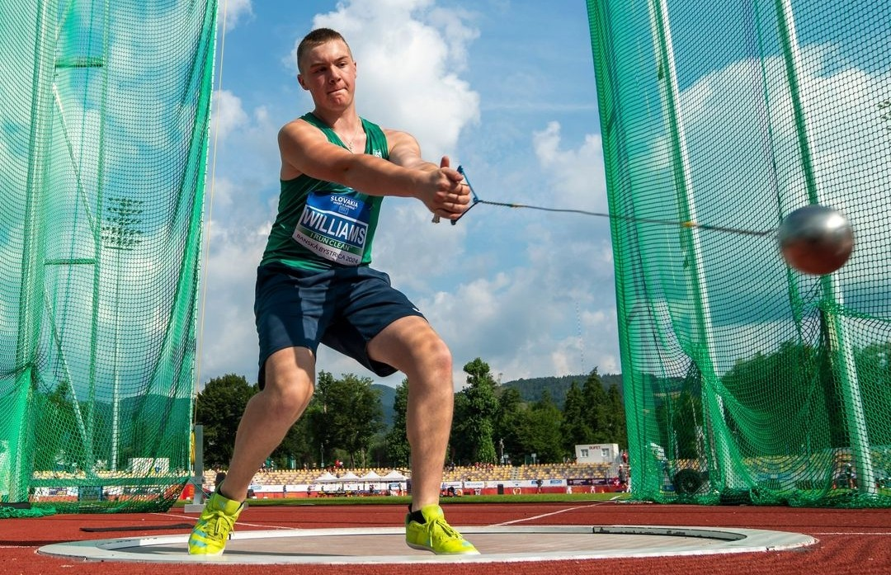

NURTURING JUNIOR TALENT
ASPIRING TO SENIOR SUCCESS
VISION
Our vision is to inspire more athletes of all abilities and backgrounds to fulfil their long-term potential, have a lifelong love for the sport, and ensure an inclusive sport where everyone belongs and can flourish. In support of this, we aim to identify and develop talented junior athletes and raise their potential for senior success. We are focused on improving physical qualities, sporting knowledge, psychological skills and performance behaviours in young athletes whilst educating parents and coaches on what it takes to perform consistently on the international stage as seniors. In doing so we believe Northern Ireland will develop a pipeline of junior athletes prepared to represent Northern Ireland, Ireland, or Great Britain at major championships.

Mission

We seek to increase participation and performance success in athletics at all levels and across all disciplines, ensuring a positive and enjoyable experience for all. We will provide opportunities and enter partnerships that will inspire and empower organisations and individuals of all ages, genders, races, and abilities to achieve their full potential. We aim to promote safety, wellbeing, equality, and positive social impact.

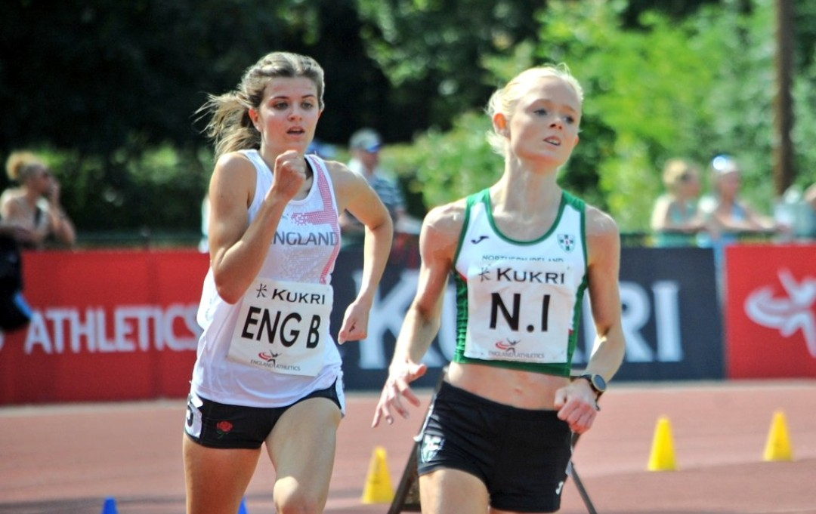
OUR VALUES

- Integrity
- Accountability
- Transparency
- Excellence
- Fun

2025-2026 Season Highlights

European Cross Country Championships 2025, Lagos, Portugal
Last year, seven youth academy athletes (past and present) from Northern Ireland were selected to represent Team Ireland at the European Cross Country Championships in Lagos, Portugal. Notably, Nick Griggs won U23 gold and led the Irish team to gold supported by Callum Morgan, Niall Murphy, and Jonas Stafford.

World Indoor Championships
Kate O’Connor (Pentathlon), Lauren Roy (60m) and Nick Griggs (3000m) represented Ireland at the World Indoor Championships in Torun, Poland. Each athlete had their own success story with Kate winning a bronze medal for Team Ireland while Nick and Lauren finished top 10 and 20 in the world, respectively.

Commonwealth Games
This year, six athletes (Kate O’Connor; heptathlon, Anna McCauley; heptathlon, Nick Griggs; 5000m, Callum Morgan; 5000m, James Gormley; mile, and Eve Walsh Dann; 100m and long jump) were selected to represent Northern Ireland at the Commonwealth Games in Glasgow, Scotland. Kate won her first Commonwealth gold while Anna had an excellent 8th place finish in the same event. In the 5000m, both Nick and Callum finished 6th and 15th, respectively. James and Eve also performed well in their events.

European Championships
Kate O’Connor (Heptathlon), Lauren Roy (100m,200m, 4x100m relay) and Nick Griggs (5000m) represented Ireland at the European Championships in Birmingham, England. Another historic gold for Kate and new Irish record. Lauren was part of the 4x100m relay team that set a new Irish record in the heats before placing 7th in the final. Another fantastic performance from Nick, despite losing a shoe in the final laps of the race!

UK Schools Games
17 - U18 athletes attended the 2026 iteration of the School Games Finals at Loughborough University from Thursday 3rd to Saturday 5th September. This year’s Games were the first to use the Dynamic New Athletics (DNA) format which culminated with the Hunt relay at the end of each day. Everyone who attended performed well in what is a late in the season and a high-quality competition with some of the best the athletes in the UK for that age group competing. The mixed 4 x 400m team who had never raced together before won the event during both days of competition.
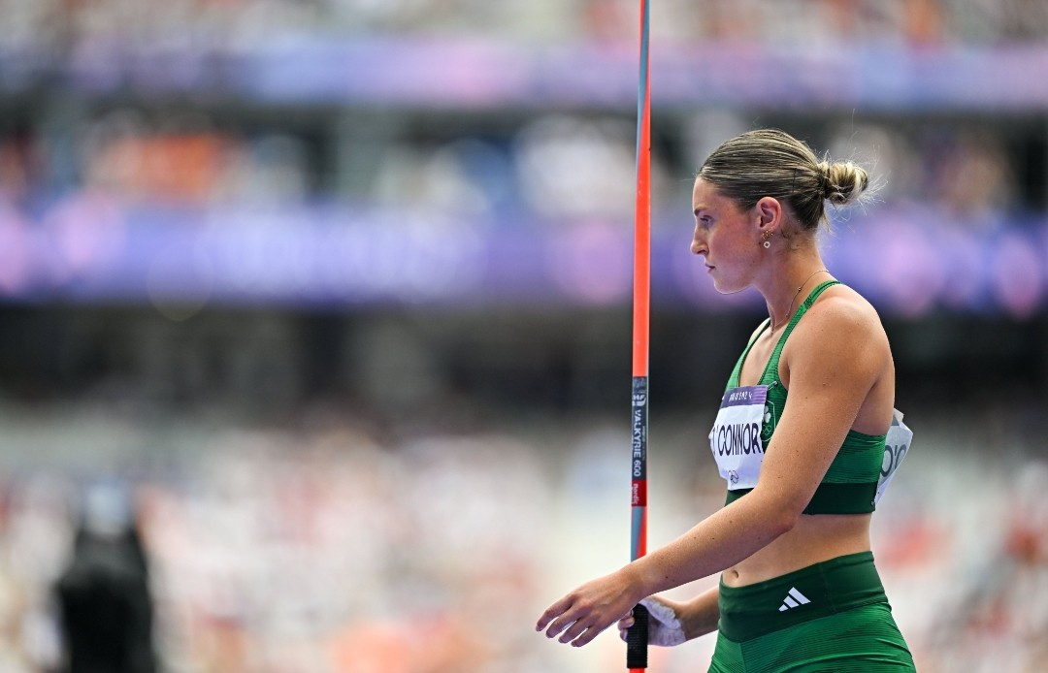

ACADEMY STRUCTURE & SUPPORT FOR 2026-27

In October 2026 athletes aged under 22 years old will be eligible to apply to Youth Academy:

Youth Academy (for NI and Ulster eligible athletes aged between 14-22 years old)

YOUTH ACADEMY SERVICES

Athletics Northern Ireland Youth Academy is based at Ulster University, Jordanstown; and Meadowbank, Magherafelt. Physical preparation sessions are delivered weekly which include speed development, and strength and conditioning support from qualified coaching staff. Delivery will start on the week beginning on the 2nd of November 2026.

Youth Academy will offer the following support dependant on relevance to the athlete-coach pair applying:

- Weekly sessions focused on speed development, and strength and conditioning support.
- Educational support: Athletics Northern Ireland plan to provide education support on nutrition, recovery, mindset, and training/competition planning.
- Routine performance testing will be collected and used to establish benchmarks for training and competition, talent identification purposes, and determine the effectiveness of training intervention.
- Additional support: Academy athletes tracking towards major championships may be afforded additional support.

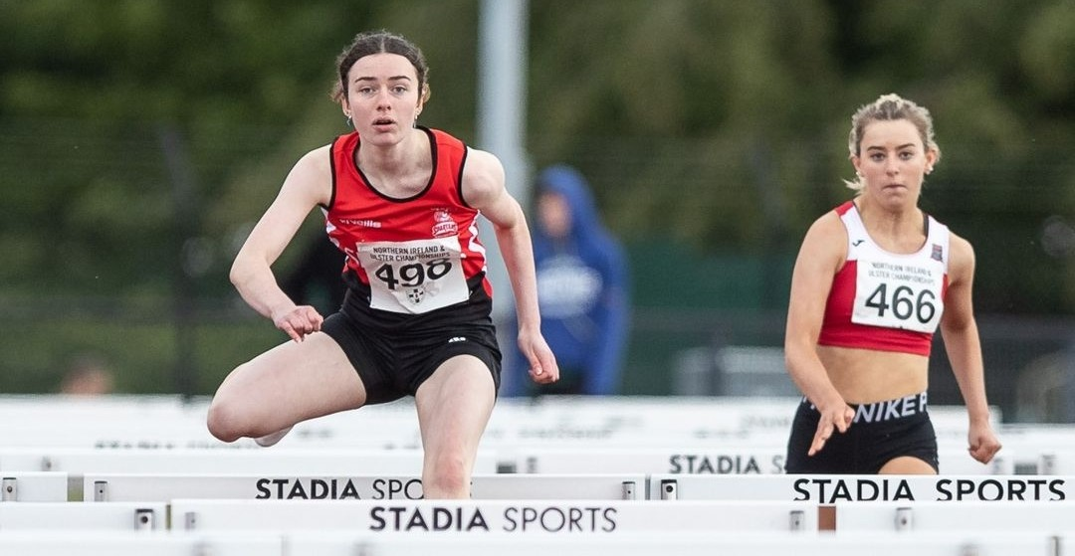

ELIGIBILITY FOR YOUTH ACADEMY

An athlete must be able to represent Northern and Ulster at age-group and senior championships. To be eligible for selection athletes must have at least one of the following criteria:

- Born in NI
- Have at least one parent born in NI
- Have three years residence in NI
- Ulster eligible (from one of the additional three counties of Ulster)
- Grandparent born in NI

RETENTION

Youth Academy is designed to deliver a 2-year curriculum. It is expected that for 2026-2027 there will be considerable interest from new applicants and spaces are not guaranteed for those athletes reapplying who have not shown upward progress. Occasional extensions are made for an athlete who has entered very young and would benefit from an additional year of support to assist with their first-year transition to university. If an athlete is on track to qualify or compete at a major championship (i.e., junior or senior) time in the academy may be extended.

WEEKLY DELIVERY

YOUTH ACADEMY *

Monday: 5pm-7pm (UU Jordanstown)

Wednesday: 5pm-7pm (Meadowbank, Magherafelt)

Friday: 5pm-7pm (UU Jordanstown)

*It is important to note that Ulster University are making changes to their facilities at Jordanstown that may impact the delivery of Youth Academy sessions in April 2027. If access to the gym and track are no longer available at this time, remaining sessions will take place at an alternative location in the Belfast area. Details to be confirmed.

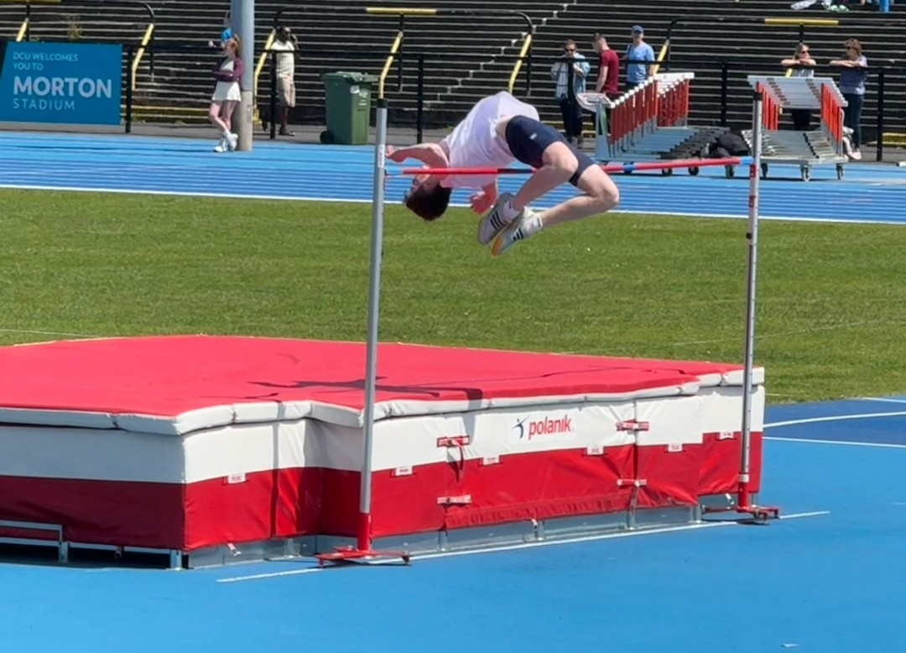

FEES

For successful applicants the academy fees for the 2026-2027 year (November 2026 to June 2027) are as follows:

Youth Academy Jordanstown - £350
Youth Academy Magherafelt - £350

Payments will be requested at the time of offer with full payment required prior to the start date (November 2nd, 2026).

LOOKING BEYOND YOUR ACADEMY EXPERIENCE

Youth Academy staff will support athlete transitions for those leaving Northern Ireland for university. Staff will also support other Academy exits by meeting with athlete-coach pairs to discuss next steps and areas for progress. We will help you identify what level of performance will be required for inclusion on the Commonwealth Potential Programme and discuss how athletes can best tap into the support personal coaches, clubs and universities offer.

Inevitably, not all Youth Academy Athletes will make the Commonwealth Potential Programme, but the Academy systems are designed to create upward pressure on the pathway and increase the number who do. By raising the potential of athlete-coach pairs we will increase the probability that talented juniors will progress to a major championship whilst also increasing the quality of national level athletes for Northern Ireland teams.

APPLICATION & SELECTION

Youth Academy aims to support athletes and coaches who have identified their own strengths, weaknesses and areas for progress and who will benefit most from engaging with the physical preparation, physiotherapy and performance lifestyle support available. Selection will prioritise athletes who demonstrate the potential and ability to eventually represent Northern Ireland at a Senior Commonwealth Games.

Selection Criteria

There are no specific entry standards for Academy Selection as limited Academy capacity means athletes across all events must be compared.

Athletes will be assessed for inclusion based upon their performance standards and performance potential.

Performance

- Track and Field performances will be assessed by comparison to European Athletics Minimum Championship Standards for European U18, U20 and U23 Championships. Consideration for road, cross country and mountain running performances will be made.

- Performance levels will also be compared to Power of 10 Rankings and Power of 10 Top 10 Targets. These Power of 10 targets will be especially useful in considering U16 athletes who cannot be compared to European Athletics U18 standards.

Potential

- Potential for senior success will also be considered. Coaching partnership, commitment to the sport, maturation, peaking age for event, demonstration of ability and mindset to access support available will all be considered. The selection panel will discuss:

    - Coaching relationship and training environment
    - Use of Academy services to date
    - Training history
    - Training gaps
    - Motivation
    - Commitment to athletics and balance with other sports
    - Coach engagement
    - Injury history
    - Availability and mindset to engage with the programme for maximum impact
    - Previous year’s attendance

SELECTION PROCESS

- Athletes who apply will be compared to each other based on performance, potential and ability to engage with the programme.

- Athletes will then be ranked in priority order for selection.

- Athletes will be offered places based on total capacity.

- There will be an event group quota in line with Athletics NI’s 2023-28 Strategy which aims to equally promote all four event groups (Jumps, Throws, Sprints & Endurance) which may affect the priority ranking of athletes in this process.

APPLICATION

Athlete-coach pairs should discuss and complete the online application form by midnight on Wednesday 14th October 2026.

We recommend that athlete and coach discuss the completion of this form and parents of U18 athletes are closely involved in the application process.

A panel will deliver the selection process on the week commencing 19th October 2026. All applicants will receive communication by Monday 26th October 2026.

